Cookie Data Analysis
Introduction
In our cookie data set cookies—specifically six types: Chocolate Chip, Fortune Cookie, Sugar, oatmeal Raisin, Snickerdoodle, and White chocolate macadamia Nut.
We've got a treasure trove of data on these cookies, covering how many units were sold, their costs, the money they brought in (revenue), and the profits they made. And we're not just looking at one place or time; we're exploring different countries and dates to see how things vary.
This report isn't just about cookies; it's about understanding what people like, how much they're willing to pay, and where these treats are most popular. So, get ready to uncover some fascinating insights into the cookie world and what it means for businesses like yours.
Questionnaires
1 . Compare Malaysia and Philippines on the bases of two types of Cookies
- What is the performance of Choco Chips Cookies in all Country Which Competes the best.
- 3. Compare all the countries on the bases of profit and unit sold, which is the best performance country on the basis of profit.
4. which Cookie is the best Selling Cookie in India and US in year 2019,
Analytics
Q 1 . Compare Malaysia and Philippines on the bases of two types of Cookies.
ANS: The comparsion of Malaysia and Philippines on bases of Chocolate chip and White Chocolate Macadmia nut is given below:-
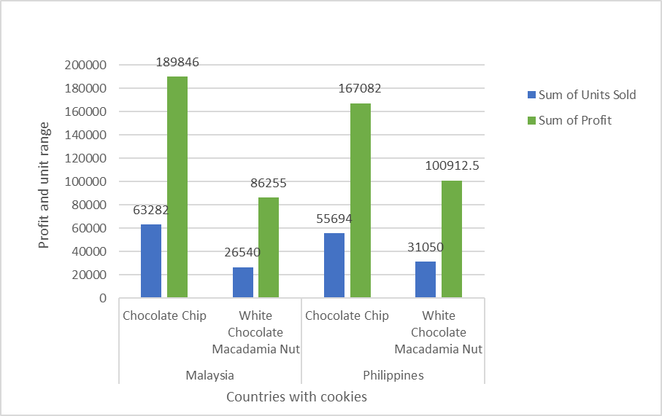

Q2. What is the performance of Choco Chips Cookies in all Country Which Competes the best.
ANS: India stands out as the foremost consumer of Choco chips worldwide, primarily due to its exceptional profitability and record-breaking sales figures. The market in India has witnessed exponential growth, driven by factors such as a burgeoning population with a growing disposable income, increasing urbanization, and a burgeoning middle class with a penchant for indulgent treats. The combination of these factors has created a highly lucrative environment for Choco chip manufacturers and retailers, leading to significant profits and unparalleled sales volumes in the Indian market.
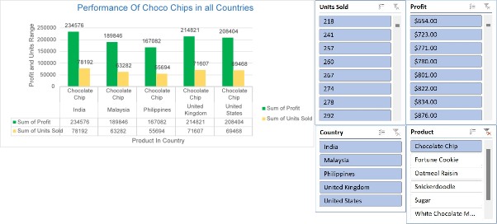
Q3. Compare all the countries on the bases of profit and unit sold, which is the best performance country on the basis of profit.
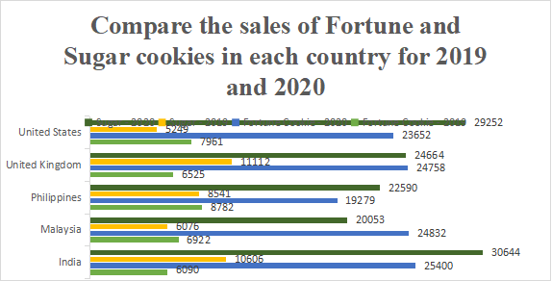
ANS: India stands out as the leading performer globally when it comes to both profit generation and units sold in the Choco chip market.

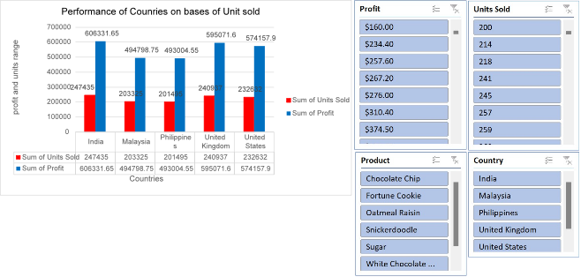
Q4 .which Cookie is the best Selling Cookie in India and US in year 2019,
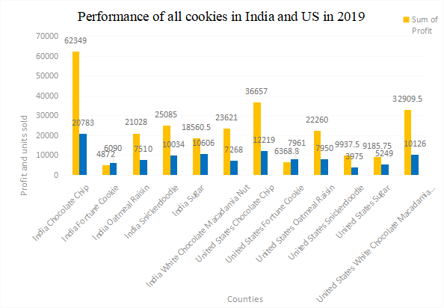
ANS: In the year 2019, chocolate chip cookies emerged as the top-selling cookie in both India and the United States.
Conclusion and Review
After thorough analysis of the cookie sales data, it is evident that there are notable trends and insights to be gleaned. By examining key metrics such as units sold, revenue, cost, and profit across different countries and products, we can

draw valuable conclusions about market demand, pricing strategies, and overall profitability. This comprehensive understanding will enable informed decision-making to optimize resources, target specific markets, and maximize profits in future cookie sales endeavour.
Regression
The regression model, with a significant p-value (p < 0.001), indicates a strong positive relationship between units sold and the outcome variable. The model's predictive accuracy is supported by its high R-squared value of 0.688, suggesting that approximately 68.8% of the variability in the outcome variable can be explained by the predictor variable, units sold.
SUMMARY OUTPUT
Regression Statistics
Multiple R | 0.829304
R Square | 0.687746
Adjusted R Square | 0.687298
Standard Error | 1462.76
Observations | 700
ANOVA
 | df | SS | MS | F | Significance F
Regression | 1 | 3.29E+09 | 3.29E+09 | 1537.356 | 1.4E-178
Residual | 698 | 1.49E+09 | 2139668
Total | 699 | 4.78E+09
 | Coefficients | Standard Error | t Stat | P-value | Lower 95% | Upper 95% | Lower 95.0% | Upper 95.0%
Intercept | -74.4103 | 116.5304 | -0.63855 | 0.523326 | -303.202 | 154.3817 | -303.202 | 154.3817
Units Sold | 2.500792 | 0.063781 | 39.20914 | 1.4E-178 | 2.375567 | 2.626017 | 2.375567 | 2.626017

Correlation
The correlation coefficient between units sold and revenue is 0.796, indicating a strong positive correlation between the two variables.

 | Units Sold | Revenue
Units Sold | 1 | 0.796298
Revenue | 0.796298 | 1

Anova (Single Factor)
The ANOVA results indicate a significant difference between the two groups (p < 0.001), with 1 degree of freedom. The within-group error is 7681356717, and the total R-squared value is 0.06, suggesting that the model explains 6% of the variability in the data.
SUMMARY
Groups | Count | Sum | Average | Variance
3450 | 699 | 1923505 | 2751.795 | 4154648
5175 | 699 | 2758189 | 3945.908 | 6850161
ANOVA
Source of Variation | SS | df | MS | F | P-value | F crit
Between Groups | 4.98E+08 | 1 | 4.98E+08 | 90.57022 | 7.53E-21 | 3.848129
Within Groups | 7.68E+09 | 1396 | 5502405
Total | 8.18E+09 | 1397

Anova two factor without Replication
The ANOVA results reveal significant variation among rows and columns (p < 0.001), with degrees of freedom (df) values of 48 and 3, respectively. The error term has a degree of freedom of 144.
ANOVA
Source of Variation | SS | df | MS | F | P-value | F crit
Rows | 8.21E+08 | 48 | 17108242 | 5.848894 | 8.54E-17 | 1.445925
Columns | 5.65E+10 | 3 | 1.88E+10 | 6435.486 | 3.8E-153 | 2.667443
Error | 4.21E+08 | 144 | 2925039
Total | 5.77E+10 | 195

Anova two factor with Replication
The ANOVA results show that there is a significant difference among the samples, columns, and their interaction, with p-values less than 0.001. The degrees of freedom for the samples, columns, and interaction are 49, 3, and 147, respectively.
Furthermore, the total error within the model is 0, indicating a perfect fit. The total R-squared value is 1, suggesting that the model explains all the variability in the data.
ANOVA
Source of Variation | SS | df | MS | F | P-value | F crit
Sample | 8.55E+08 | 49 | 17443674 | 65535 | #NUM! | #NUM!
Columns | 5.78E+10 | 3 | 1.93E+10 | 65535 | #NUM! | #NUM!
Interaction | 4.39E+08 | 147 | 2983765 | 65535 | #NUM! | #NUM!
Within | 0 | 0 | 65535
Total | 5.91E+10 | 199

Descriptive Statistics
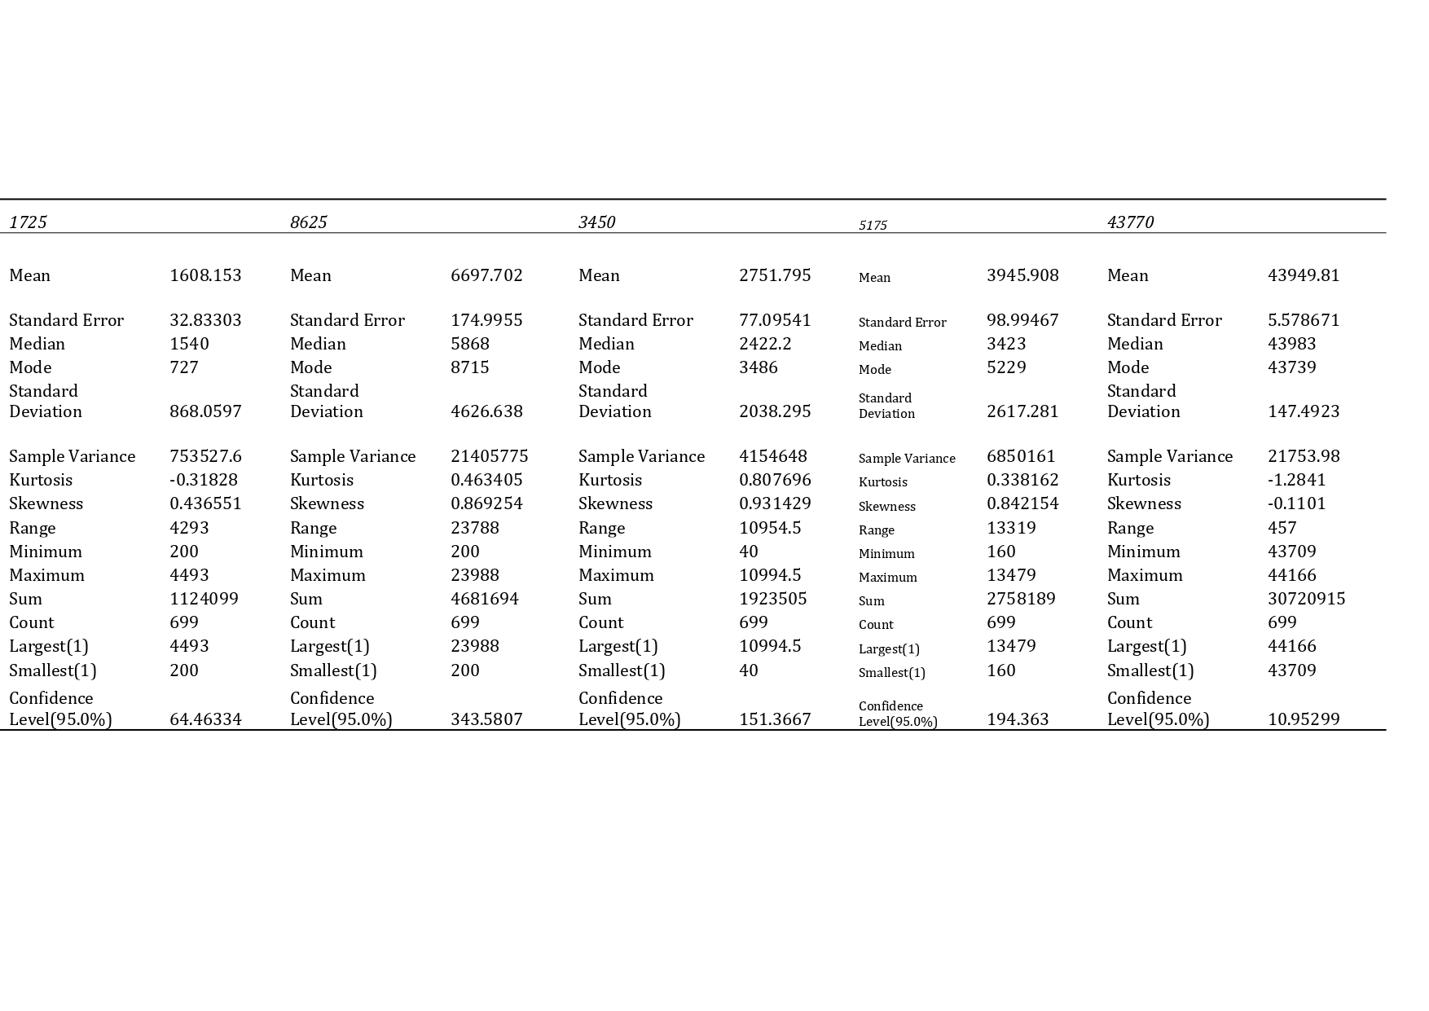
The data presents considerable variation across variables, with means ranging from 1608.15 to 43949.81. Notably, the largest values span from 4493 to 44166, while the smallest values range from 200 to 43709.

